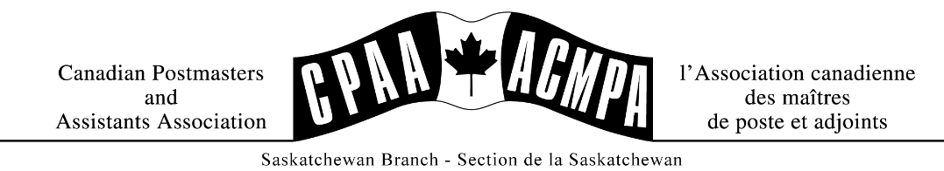
July 2025
BRANCH BULLETIN

On June 13, 2025, CPAA and CPC reached a negotiated agreement, with help from the Arbitrator. Instead of utilizing the final offer selection process, the arbitrator was able to help CPAA and the Corporation reach a resolution that both agreed was in the best interests of both parties. In the final offer selection process, the arbitrator is given both packages to review prior to both parties presenting their arguments. Because the arbitrator felt that the two parties weren’t that far away from reaching a negotiated collective agreement, she asked if the two parties would return to the bargaining table and let her facilitate that process further. Also, in the week prior to arbitration week, CPAA and the corporation met and were able to resolve some outstanding issues. By the time this issue comes out, our members should have received letters from the Corporation regarding the newly bargained collective agreement.
The Saskatchewan board would like to thank our bargaining team: Yolanda Kreitzer, Janet Johnson, Dwayne Jones and Alison McEwen and colleagues at Ravenlaw for their hard work and dedication to CPAA during this round of bargaining. They’ve spent countless hours wading through demands, spending many nights away from home and working diligently to come to an agreement with the employer that reflects our members’ needs.

COLLECTIVE AGREEMENT REACHED WITH CANADA POST!

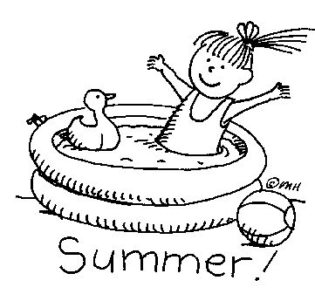
More on the new Collective Agreement
Here are some key highlights of the new Collective Agreement:
- An 11% wage increase over 3 years, retroactive to January 1, 2024 (6% increase in 2024, 3% increase in 2025, and 2% increase in 2026)
- A childcare fund will be established and managed by CPAA
- The travel policy for CPAA-represented employees will be the same that covers management, UPCE and APOC-represented employees
- Increases in the leasing allowance for postmasters who provide postal services in their own facilities
- Employees who are employed with the Corporation on the date of signing will also receive a non-pensionable lump sum payment ($1000 for all postmasters and other employees classified as full-time; $500 for all other employees)
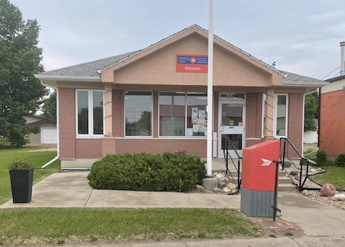

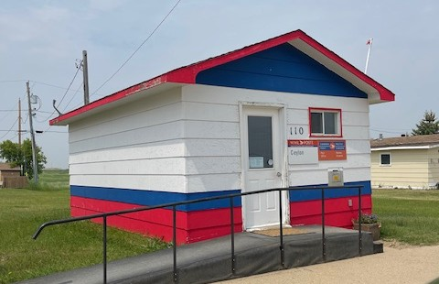
Post Office Visits
The board has been working diligently to visit post offices in the last couple of months. We hope to visit more offices in the fall.
Term Employees and the Canada Labour Code – Medical Leave Days
Under the CLC terms are eligible and entitled to medical leave days. This information can be found under the Canada Labour Code – Medical Leave with Pay – IPG 118. This information will explain how you accumulate medical leave. You can request a copy of the 2022 CLC Changes booklet from your LAS.
You must be scheduled to work to use these medical leave days.
You must contact your LAS or AccessHR as they are able to view your leave balances and let you know how many days you have. As a term you cannot view this information through SAP.

Leasing Allowance Increases
With the signing of our new Collective agreement, postmasters who provide the premise will receive: 2024-5.5%, 2025- 3.5% and 2026- 3.5%! This is a good step in the right direction, but if you’re still not receiving enough to cover expenses, postmasters are entitled to ask for an increase in their leasing allowance based on the expenses they are incurring to provide the premise.
If your expenses still outweigh the income received from CPC to provide the premise, then ask for an increase.
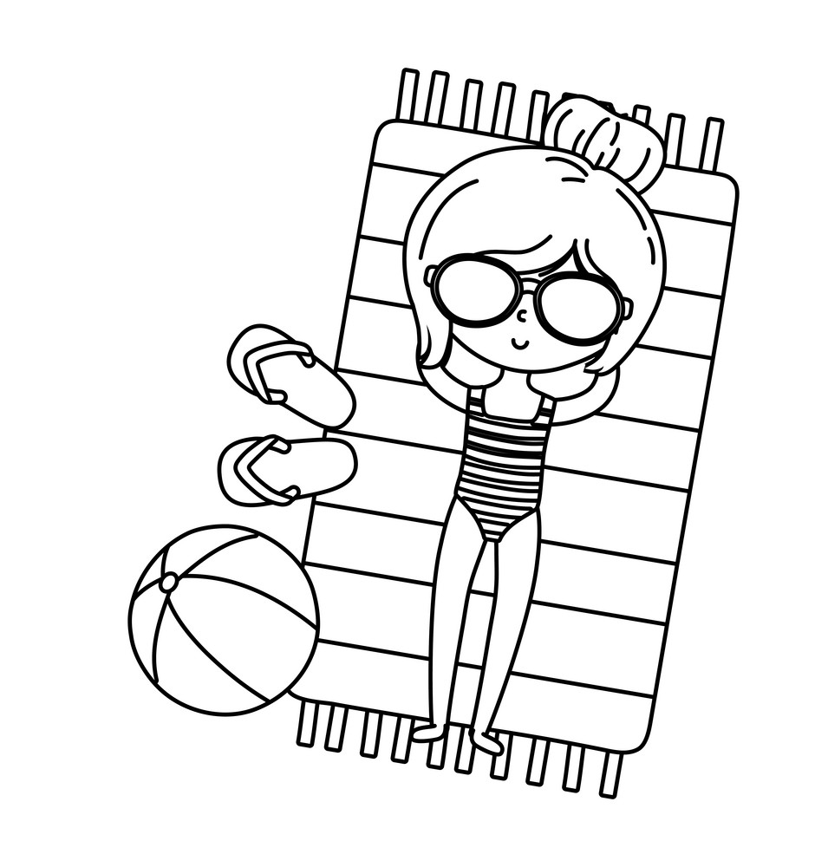
New Hires, Promotions, Retirements
New Hires – Welcome!
Kelly Crane - Cumberland House
Tracy Mumm - Shellbrook
Colette Lacoursiere - Unity
Kim Randall - Regina Beach

Promotions – Congrats!
Silvia O’Brien - La Ronge
Jacqueline Natske - Unity
Cynthia Popoff - Leask
Harley Brass - Wadena
Jessica Charles - La Ronge
Jacqueline Fawns - Tuffnell
Vanessa Hebson - Maidstone
Jessica Werbeski - Balcarres
Payten Materi - Alsask
Tracy Maderash - Wynyard
Jo-Anne Kollman - Rhein
Bonnie Lazurko - Grayson

Retirement – Good luck on the next chapter!
Pauline Stuart - Turtleford
Barbara Puryk - Margo
Gayle Skeet - Craik
Roxanne Talbot - Hudson Bay

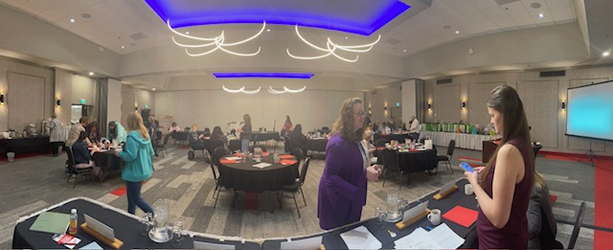

Convention 2025
The 102nd Annual Convention was held during the weekend of April 25th and 26th at the very beautiful Ramada Plaza by Wyndham Regina Downtown. Convention opened on Friday evening with registration and an evening of socializing at Kookie’s Lounge on the main floor of the hotel. Of all present, there was 1 National Officer, 4 Branch Board Officers, 29 voting members of which 7 were first time attendees, 1 Lifetime Member, and 7 guests.
The formal business of Convention began on Saturday morning, when attendees were presented with the 2024 audited financial statement and the 2026 budget. We were pleased to welcome our National Vice-President (English), Judy Potter, who presented the National President’s Report, followed by an open forum. Three PowerPoint presentations/workshops were each facilitated by a Branch Board officer. The workshop topics included Burnout, Leave Entitlements, and Staffing.
Our Saturday evening concluded with a delicious buffet supper, served in the Canadian Ballroom of the hotel, courtesy of the Saskatchewan Branch of CPAA. An evening of comedic entertainment provided at Yuk Yuk’s Standup Comedy Club at Fibber McGee’s Pub was enjoyed by all.
We gratefully acknowledge the generous donation of a variety of items which were raffled off on Saturday afternoon. The proceeds of the draws were $370.00, and all funds were donated to STARS. Following the adjournment of our convention, attendees and their guests said farewell for another year, in anticipation of gathering together again next year!

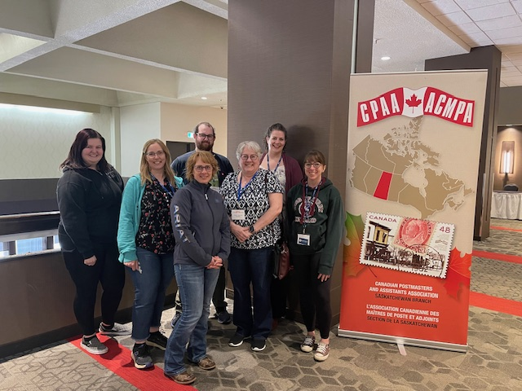
$1000.00 SCHOLARSHIP
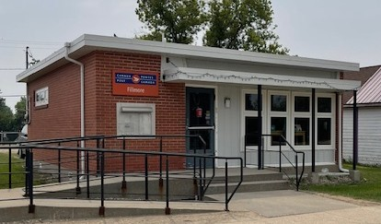
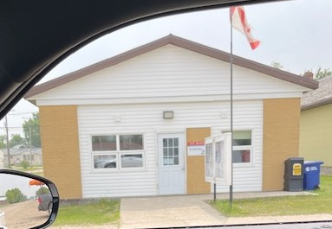
First-Time Attendees!
This year we had 7 first-time attendees at our 102nd Convention, held in Regina, SK, this year. We love to see this! Thank you so much for coming! Thank you also to the members who encouraged our first timers to attend. We hope to see everyone again next year!
Back Row: Allyson Parker, Nolan Wentzel, Meghan Folnovic
Middle Row: Candice Schropp, Rosey Eyolfson, Chelsey Griffin
Front Row: Candice Newman

The Saskatchewan Branch Board of Directors has created a $1000.00 scholarship for a student who will graduate from Grade 12 in 2025 and who will be attending a Post-Secondary Institution in the fall of 2025.
The Branch Board of Directors would like to call for submissions for our $1000.00 Scholarship for children or grandchildren of any “Active” Saskatchewan CPAA-ACMPA Member.
Student Name:_________________________________________________________________
Address:_______________________________________________________________________
Phone Number:_________________________________________________________________
School Last Attended:____________________________________________________________
(Please enclose a copy of your most recent transcript.)
Post-Secondary School Registered At:_______________________________________________
Active Member Name:___________________________________________________________
Post Office Employed At:_________________________________________________________
Relationship to Applicant:________________________________________________________
***Please include this form with your application***
Qualifications to Apply for the Scholarship:
- Applicant must be entering in their first year of post-secondary education at a university or college. Proof of registration must accompany the essay.
- Children and grandchildren of CPAA-ACMPA members are eligible (proof may be required).
- Applicants can only win once.
- Saskatchewan Branch Board will select the winner.
- One entry does not default to winner.
- Essay must be written in your own words.
- Bibliography to accompany essay.
- Essay to be a minimum of 1000 words.
Please enclose your photo – if you are the recipient, it will be put into the newsletter!
Applicants are asked to write a minimum 1000-word essay, complete with bibliography, on the following question: “How has having a family member in a union inspired you?”
The recipient of this scholarship will be chosen from the entries which have met all the criteria and will receive a $1000.00 cheque upon confirmation of registration in a post-secondary institution.
Please mail your entry to:
CPAA SK Branch, PO Box 189, Hawarden, SK S0H 1Y0

All applications must be received by October 31, 2025
Term Employees and Continuous Service
Many term employees ask how do they achieve continuous service, and how do they maintain continuous service?
In order to gain your continuous service, you must work 1 shift in 7 calendar days. For example, if you work Tuesday of this week, and Friday of the following week, that does not count towards your continuous service. If you work Tuesday of this week, then you must work 1 shift by Tuesday of the following week.
In order to maintain your continuous service, you must work 1 shift in 30 days, not 1 month. Some months have 31 days, and that is considered a break in service.
It is very important for terms to make sure they are keeping track of their shifts worked. The most accurate way to do this is to keep your copy of your timesheet(s). When a term achieves continuous service, they should receive a letter from AccessHR. When you receive this letter, you should show the Postmaster in your post office.
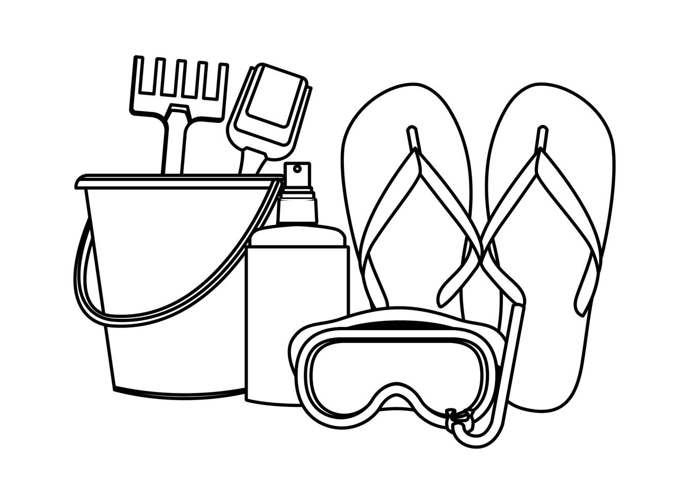
Information Bites…
Please make sure you’re receiving the correct pay when you’re in an acting assignment. Check your paystub! It’s easier to fix this error when caught sooner rather than later.
If you need to reach out to a Union board member, please email us from your home computer, not the RPOS. We do not receive emails from the RPOS.
Peanut Buster Bar Dessert
Bottom Crust:
1 – 15oz pkg. Oreo cookies – crushed
½ cup of butter – melted
Mix together and put in a 9 x 13 pan. Press down and chill for 1 hour.
Filling:
2 litres of vanilla ice cream – softened
1 cup of chopped peanuts
Spread ice cream on crumb crust. Sprinkle with peanuts and freeze.

Topping:
2 cups of icing sugar
1 cup of evaporated milk
1 cup of chocolate chips
½ cup margarine
Cook topping for 8 minutes or until thick. Cool slightly and pour over ice cream layer. Freeze. Take out 15 minutes before serving.


USEFUL CONTACTS
ACCESS HR
Phone : 1-877-807-9090
Fax : 1-613-734-6347
Email : accesshr@canadapost.ca

TELUS Health/Canada Life – STDP
Phone: 1-855-554-3148

CANADA POST PENSION CENTER
Phone: 1-877-480-9220
Website: cpcpension.com

WORKERS COMPENSATION BOARD (WCB)
Phone: 1-800-667-7590
Website: wcbsask.com

CANADA LIFE BENEFITS
Phone: 1-866-716-1313
Website: canadalife.com

EFAP (EMPLOYEE AND FAMILY ASSISTANCE PLAN)
Phone: 1-866-565-4903
Website: https://homeweb.ca/

CPAA NATIONAL OFFICE
Phone: 1-613-745-2095
Email: mail@cpaa-acmpa.ca
Website: https://cpaa-acmpa.ca/wp/

CPAA SK BRANCH WEBSITE
www.cpaask.org

CPAA Saskatchewan Branch
YOLANDA KREITZER
PRESIDENT
Box 119
Raymore, SK S0A 3J0
306-535-1100 (O)
306-746-5840 (H)
306-746-9001 (F)
yolanda@cpaask.org

AMANDA HANNAH
VICE PRESIDENT
Box 2738
Melfort, SK S0E 1A0
306-864-3553 (O)
306-921-3936 (H)
amanda@cpaask.org

JANELLE CHRISTENSEN
SECRETARY/TREASURER
Box 144
Hawarden, SK S0H 1Y0
306-567-3118 (O)
306-855-2066 (H)
janelle@cpaask.org

CRYSTAL DUMONCEAUX
DIRECTOR
Box 2229
Fort Qu’Appelle, SK S0G 1S0
306-332-5911 (O)
306-331-8344 (H)
crystal@cpaask.org

KATHY ALEXANDER
DIRECTOR
Box 704
Raymore, SK S0A 3J0
306-554-3622 (O)
306-737-2630 (H)
kathy@cpaask.org

